“PRECISION CUPS”
TPS 2.0 LIDS AND LINERS
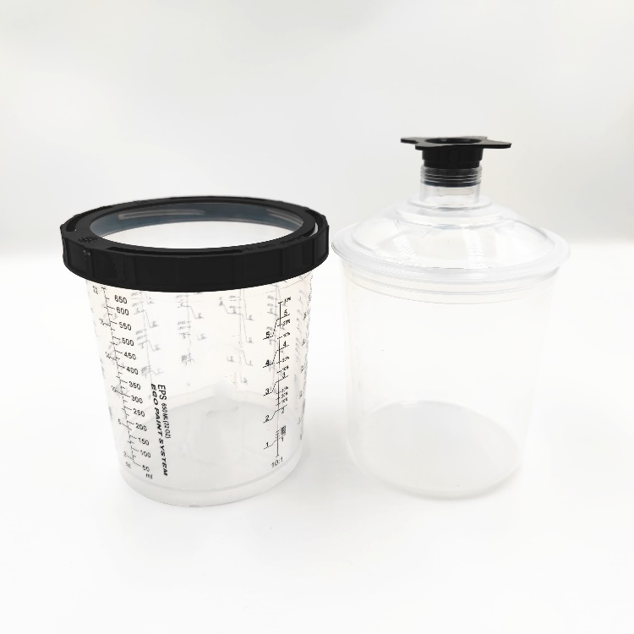
FOR MORE INFORMATION: WWW.PRECISIONCUPS.COM
AVAILABLE IN THESE SIZES:
200ML – 190
650ML - 125
$69.95
650ML – 190
850ML – 190
850ML - 125
INCLUDES: 1 Hard Cup & Collar, 50 Lids & Liners and 20 Caps
Adapters available for all brand paint guns

OR 5 FOR $250.00
PPS PAINT PREPARATION SYSTEM
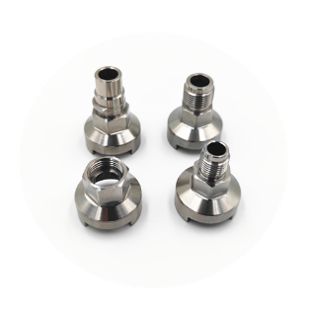
3/2024

